Renju lesson on January 4, 2001

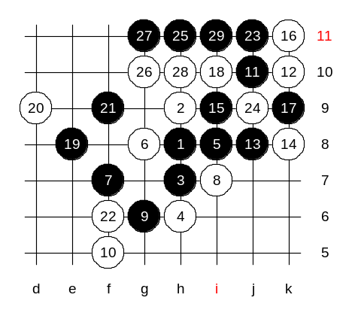
Hello all! Welcome to Online Renju Class. We will continue learning d8 opening today. Last week we played a game, teacher vs students. You could not see the VCT from the move 19. Lets try find out that VCT. Now, after the 21st move black has VCF threat. How to block? You say d7? Well, then black wins easily – i11, h10, f6, f8.
Moves 22-f6 and 22-g7 are the strongest. OK, we play f6 first. How to win? Black has an easy win here. No need for space development, just use straight win. Yes lu is right. Black wins with j11.

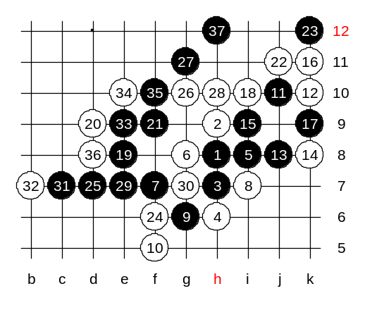
We made a conclusion that white has to play a four in move 22 and then continue to f6 or g7. Ok, we play 22-j11 and 24-f6. How does black win now? Maybe black can win on both left and right sides. Lu shows nice left side win here.

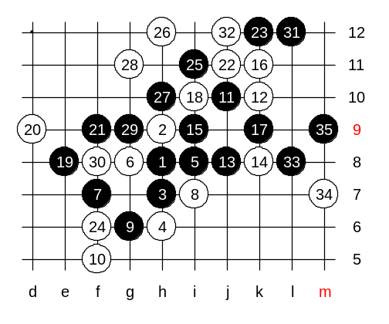
Lets see another way to win in same position.
White must play 28-g11, otherwise black plays to f11 and has two VCF threats.

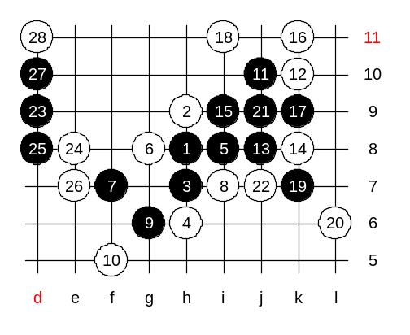
Another 18th move – i11. This move has also occurred in high level games, and black has often failed the attack since the sequence is not easy to be found. Lets see how to play here. Good thinking. You think about how to connect the right side stones with left side material. Actually, black has already 100% used its right side material – black has a four to play to either g11 or h10, and black also controls the j11 point in case of white’s counter-attack. So, now you have to focus on attacking only on left side. By the way, alula is right. Black’s only winning way begins with d9 and d8. How should white block now? If d7 then black plays c9 and wins in 2 moves.
This is the advanced level homework. Please find the black win.

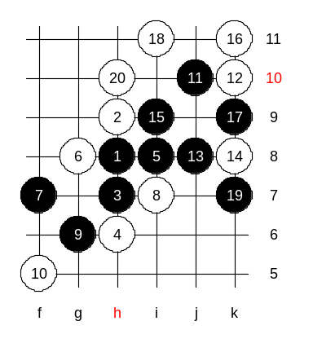

This is the medium level homework, please find the black win.

